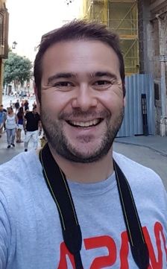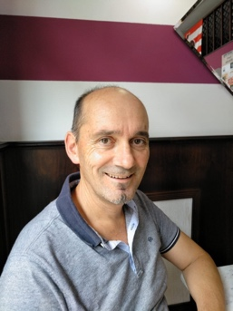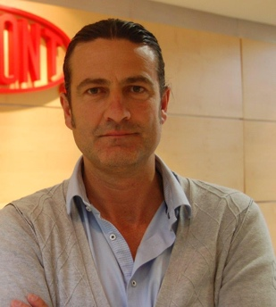

**FOR OUR RIGHTS**

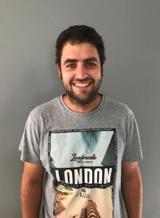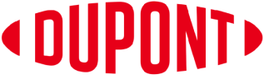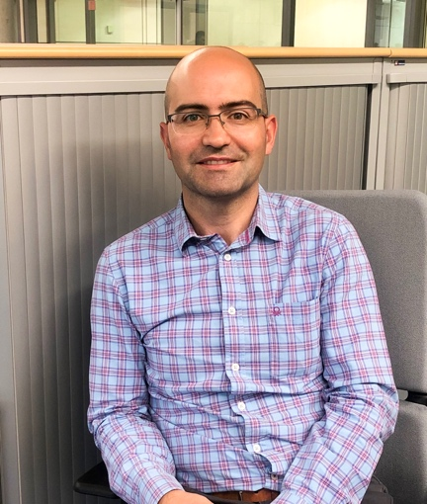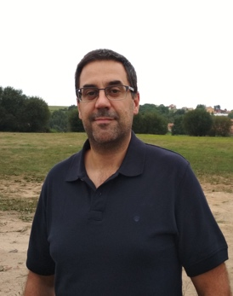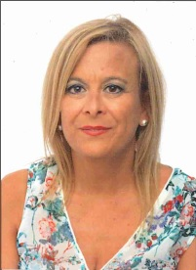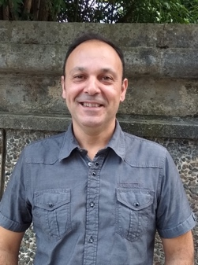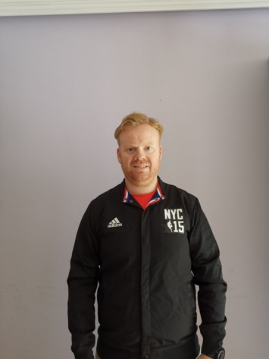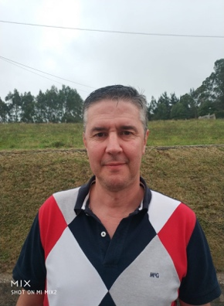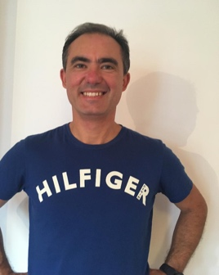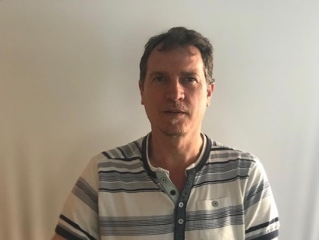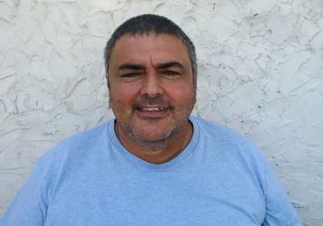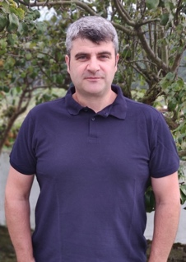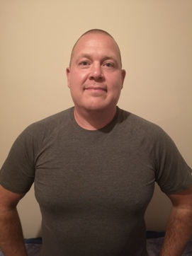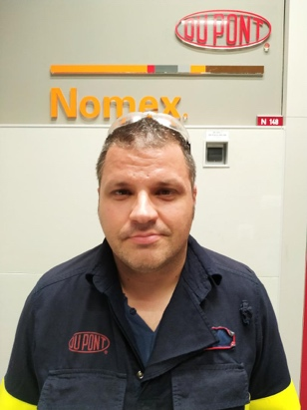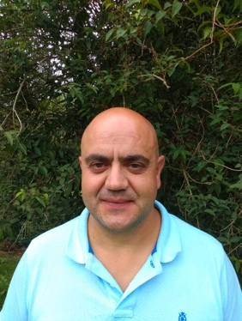

**VOTE** for your co-workers

***Come and meet us at the scheduled meetings. We will openly discuss our achievements and goals. We want to hear your voice – issues, questions and proposals.***

**8th y 9th OCT 2019**

**CANDIDATES**

Javier Leiras - Nomex®

Gongui Morán - GSB

Mª José Trevín - GSB

Carlos Díaz - GSB

Pedro Bra – ICL

Oscar Vega - Nomex®

Julio Sánchez - Nomex®

Alfonso Reca - ICL

Oscar Prieto - Nomex®

Eduardo Díaz - Nomex®

Rubén Yudego - Nomex®

Tom Olstad – GSB

Rubén López - Nomex®

Diego García - Nomex®

Juanjo Rivera - Nomex®

Sergio Díaz - Nomex®

Benjamín Alonso - Nomex®

Jesús Cepedal - Nomex®

Juan M. Fdez. - Nomex®

***To make things change, vote for your co-workers!!***

**WORKER’S COUNCIL ELECTION**

**Performance Specialty Products Asturias SLU**

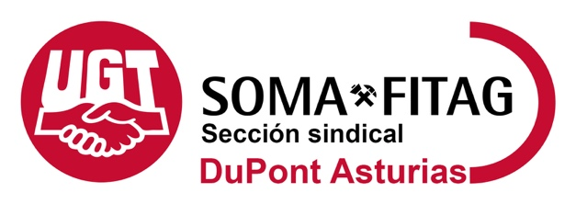

**OBJETIVES:**

* Recovering our work culture: strengthening respect for workers and valuing their opinion.
* Improving work conditions, benchmarking against companies in our sector in Spain.
* Defending jobs, anticipating social and economic challenges.
* Restructuring the valuation of our contribution, thereby avoiding the huge gaps in the distribution of variable pay and eliminating the punishing nature that has been given to this tool.
* Guaranteeing compliance of company core values.
* Listening and aiding in the demands of workers.
* Guaranteeing adherence to the work hours, avoiding extra hours and unbearable workloads.
* Improving work conditions for ALL workers who demand it, not just a few lucky ones.
* Re-establishing practical means of communication with colleagues (email)

With this election we have the **opportunity to oust a council governed by LIDA** which currently:

* Prioritizes the company’s demands.
* Votes against salary upgrades suggested by a benchmarking against the chemical sector.
* Votes against the reduction of annual work hours.
* Does not support colleagues and union representatives who have suffered reprisals from the company.
* Does not support workers’ collective demands.

**FOR YOUR HEALTH & SAFETY ALL VOICES COUNT, JOIN IN! IMPROVE YOUR WORK CONDITIONS HEALTHY WORKLOADS TRUE WORK-LIFE BALANCE FOR EQUALITY TRANSPARENCY DIALOGUE AND FREEDOM TO EXPRESS YOURSELF WE STAND FOR OUR COLLEAGUES**

Dear colleagues:

Almost four years ago we called the first union election in DuPont Asturias. During this time, union representatives have been available to safeguard your rights and help you in all issues brought to our attention. You have witnessed the work undertaken by this union group. We would have wished to have achieved more changes, fostered by a free Work Council. Unfortunately, this has not been possible due to the lack of support from LIDA- the company-sponsored group currently in charge of the Work Council.

Because of this, we requested a new election, so that **the voice of employees reaches a Council which defends their interests,** a Council which does not veto any initiative or demand coming from employees, a Council which attempts to resolve issues in a calm, transparent, agile and conciliatory manner.

**Each voice counts - JOIN in!! !!**

**REASONS TO VOTE FOR US:**

* Because safety, health and environment, as well as respect for people are our **TRUE** priority.
* So that you feel listened to, valued and informed
* So that you can **communicate freely** with the company, without filters, knowing that our sole objective.
* So that your work is compensated fairly: harmonization of salaries for employees in the same job and level. **Salary harmonization** by gender and professional group.
* Elaboration of **our own collective bargaining agreement** which improves the one we have in the Chemical sector and facilitates employment relations, hence adapting to better practices enjoyed by companies who already have such agreements.